🧠 OpenAI LLM Families
🔹 1. GPT Series (Core LLMs)
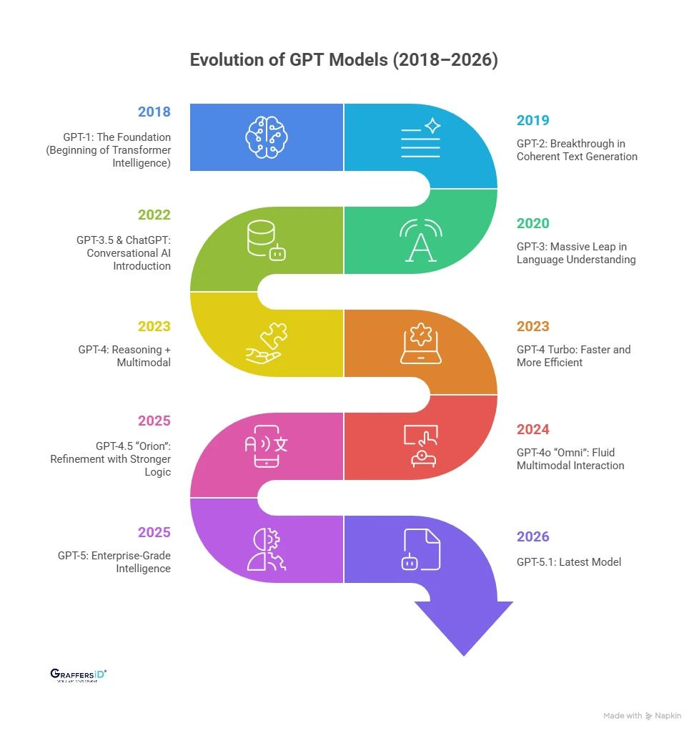
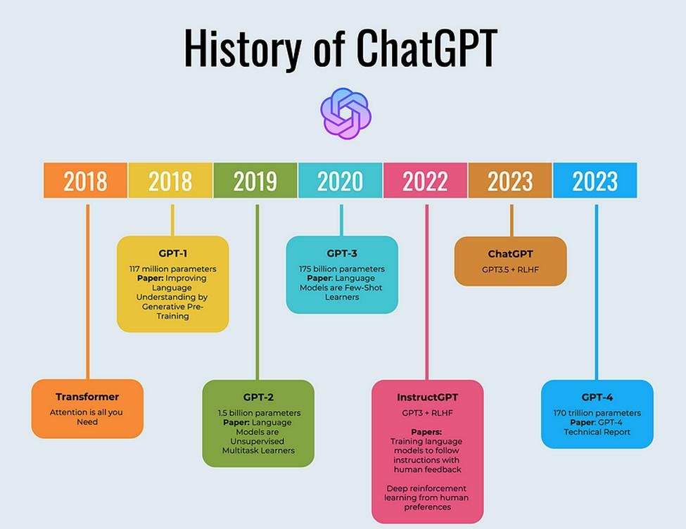
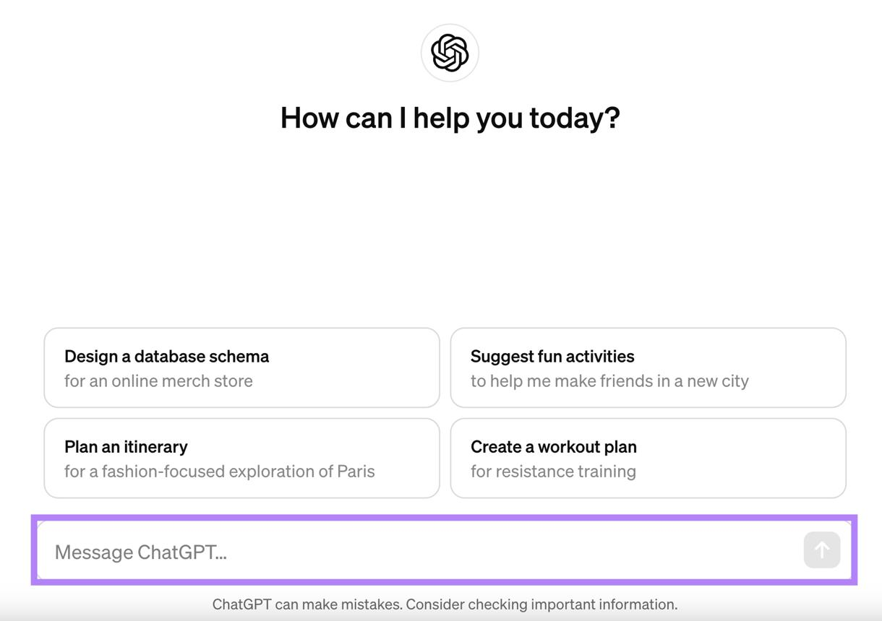
These are the main Generative Pre-trained Transformer (GPT) models:
- GPT-1 (2018) – First transformer-based LLM from OpenAI
- GPT-2 (2019) – Much larger, strong text generation
- GPT-3 (2020) – Massive leap (175B parameters)
- GPT-3.5 (2022) – Improved GPT-3 (used in early ChatGPT)
- GPT-4 (2023) – Multimodal (text + image understanding)
- GPT-4 Turbo (2023–2024) – Faster & cheaper GPT-4 variant
- GPT-4o (2024) – “Omni” model (text, image, audio)
- GPT-4o-mini – Smaller, cheaper version of 4o

🔹 2. Reasoning Models (Newer Specialized LLMs)
Designed for deeper reasoning and step-by-step thinking:
- o1 – Advanced reasoning model
- o1-mini – Lightweight version
- o3 – Improved reasoning (stronger than o1)
- o3-mini – Faster/cheaper reasoning model
👉 These are optimized for:
- Math
- Coding
- Complex logic problems

🔹 3. Embedding Models
Used for semantic search, retrieval, and RAG systems:
- text-embedding-ada-002 (older, widely used)
- text-embedding-3-small
- text-embedding-3-large

🔹 4. Older / Legacy Models
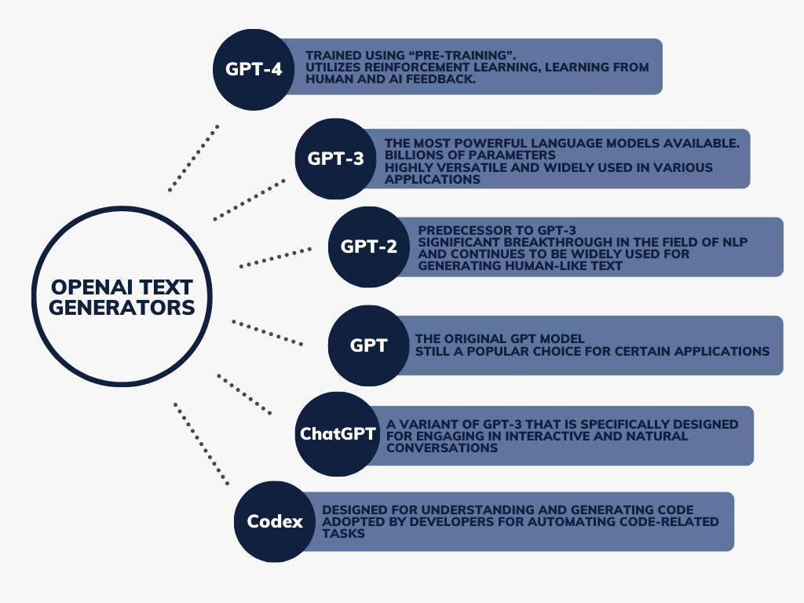
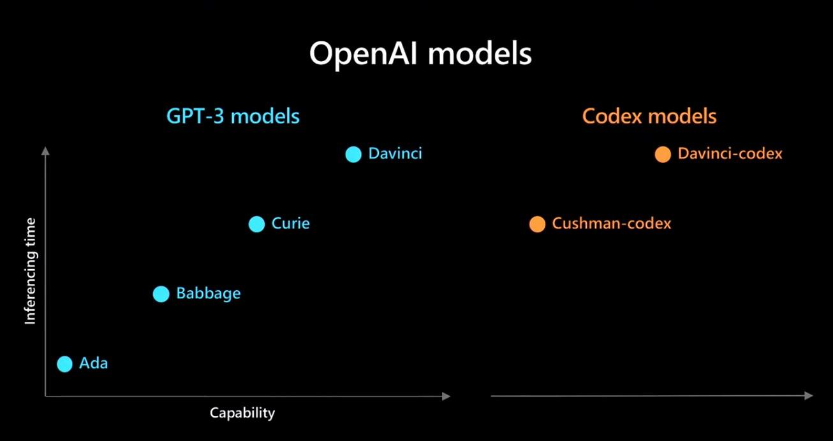
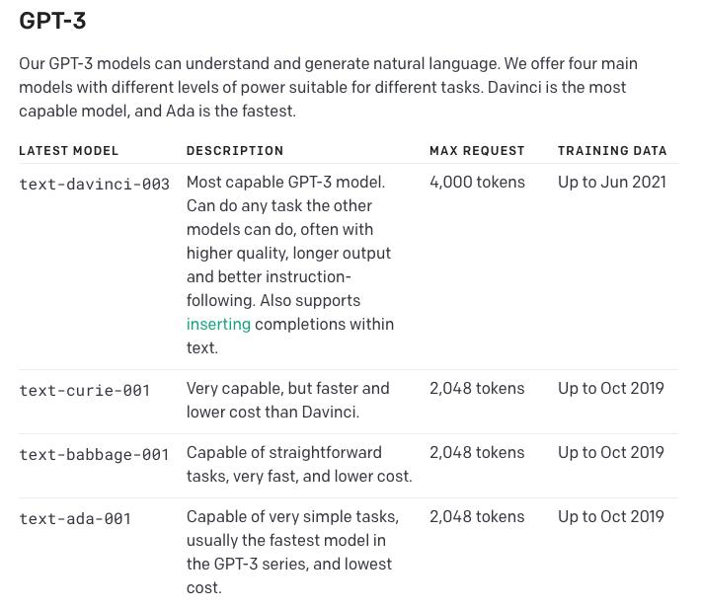
These were part of earlier APIs:
- davinci-002
- babbage-002
- curie (deprecated)
- ada (deprecated)

⚖️ Simple Classification
Type | Models
General LLMs | GPT-1 → GPT-4o
Reasoning-focused | o1, o3 series
Embeddings | text-embedding-*
Legacy | davinci, curie, ada

🧠 Key Insight
- GPT models → General-purpose (chat, coding, writing)
- o-series → Deep reasoning (like “thinking models”)
- Embeddings → Power search & retrieval systems

⚠️ Important Note
OpenAI evolves models frequently, so:
- Some older models are deprecated
- Newer models (like GPT-4o, o3) are current and preferred

